## Exercise 2 The CliffWalking Environment

## The CliffWalking Environment

In this exercise, you will examine another implementation of a grid world type environment, with a different reward structure.

Make sure that you have completed the setup requirements as described in the Set Up Lab Environments section.

Credit to [Denny Britz](https://github.com/dennybritz) for the implementation of the CliffWalking Environment

The CliffWalking environment is a simple environment of a 4x12 tiles, which has “cliffs” or terminal states on it. The initial state has the agent starting at the tile on bottom left corner, with the goal to reach the tile at the bottom right corner, avoiding the cliffs in the process.

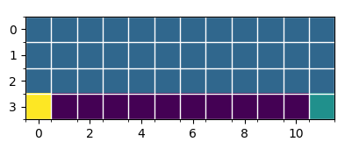

Examine the cliff_walking.py file under the lib\envs folder. Specifically, take a look at the CliffWalkingEnv class. The CliffWalkingEnv class implements the DiscreteEnv class from open AI's gym.envs.toy_text.discrete.

Take some time to study the implementation of this environment. Start by examining how the states are represented in this environment. Also, look at how the CliffWalkingEnv class implements the reset() and step() functions as these two are the ones used to interact with an agent.